

**INDUSTRY INTERNSHIP REPORT**

***Submitted in***

***partial fulfillment of requirement for the award of degree of***

**Bachelor of Technology**

**in**

**Electronics and Telecommunications Engineering**

***by***

**Mr. Aniket Khadgi**

***Industry / Organization Guide***

**Mr. Sandesh Rahate**

Principal- Technology Consulting, Modern Solution at

**Hitachi Solutions India Pvt. Ltd.**

***Institute Guide***

**Dr. Sanket Kasturiwala**

Assistant Professor

**May 2025**

**Department of Electronics & Telecommunication Engineering**

**G H Raisoni College of Engineering & Management**

An Autonomous Institute Affiliated to Rashtrasant Tukadoji Maharaj Nagpur University, Nagpur Accredited by NAAC with “ A+”Grade

Shraddha Park, B-37-39/1, MIDC, Hingna-Wadi Link Road, Nagpur-440016 (INDIA) T: +91-07104-236102 | E: [ghrcemn@raisoni.net](mailto:ghrcemn@raisoni.net) | W: [www.ghrcemn.raisoni.net](http://www.ghrcemn.raisoni.net/)

**INDUSTRY INTERNSHIP REPORT**

***Submitted in***

***partial fulfillment of requirement for the award of degree of***

**Bachelor of Technology**

**in**

**Electronics and Telecommunications Engineering**

***by***

**Mr. Aniket Khadgi**

***Industry / Organization Guide***

**Mr. Sandesh Rahate**

Principal- Technology Consulting, Modern Solutions at

**Hitachi Solutions India Pvt. Ltd.**

***Institute Guide***

**Dr. Sanket Kasturiwala**

Assistant Professor

**May 2025**

**Department of Electronics & Telecommunication Engineering**

**G H Raisoni College of Engineering & Management**

An Autonomous Institute Affiliated to Rashtrasant Tukadoji Maharaj Nagpur University, Nagpur Accredited by NAAC with “ A+”Grade

Shraddha Park, B-37-39/1, MIDC, Hingna-Wadi Link Road, Nagpur-440016 (INDIA) T: +91-07104-236102 | E: [ghrcemn@raisoni.net](mailto:ghrcemn@raisoni.net) | W: [www.ghrcemn.raisoni.net](http://www.ghrcemn.raisoni.net/)

**Declaration**

I hereby declare that the Industry Internship report submitted herein has

been carried out by me in Hitachi Solutions India Pvt. Ltd. towards partial fulfillment of requirement for the award of Degree of Bachelor of Technology in Electronics and Telecommunication Engineering. The work is original and has not been submitted earlier as a whole or in part for the award of any degree / diploma at this or any other Institution / University.

I also hereby assign to G H Raisoni College of Engineering and Management, Nagpur all rights under copyright that may exist in and to the above work and any revised or expanded derivatives works based on the work as mentioned. Other work copied from references, manuals etc. are disclaimed.

|  |  |  |  |
| --- | --- | --- | --- |
| **Name of student** | **Mobile No** | **Mail ID**  **(Other than Raisoni.net)** | **Signature** |
| Aniket Khadgi | 9422183152 | khadgianiket7@gmail.com |  |

**Place**

**Date**



**Certificate**

The Industry Internship Report entitled as **“VibeCart”** carried out under our supervision in **Hitachi Solutions India Pvt. Ltd.** by **Aniket Khadgi** for the award of Degree of Bachelor of Technology in Electronics and Telecommunications Engineering. The work submitted is comprehensive, complete and fit for evaluation.

**Mr. Sandesh Rahate Dr. Sanket Kasturiwala**

**Industry / Organization Guide Institute Guide**

Principal- Technology Consulting, Assistant Professor

Modern Solutions Department of Electronics

Hitachi Solutions India Pvt. Ltd. And Telecommunications

GHRCEM, Nagpur

**Dr. Sanket Kasturiwala Dr. Devashree Marotkar**

III Coordinator Head of Department

GHRCEM, Nagpur Electronics and Telecommunications

GHRCEM, Nagpur

**Mr. Gurpal Singh Dr. Vivek Kapur**

III Cell **Director**

GHRCEM,Nagpur GHRCEM,Nagpur

**ACKNOWLEDGEMENT**

I would like to express my sincere gratitude and appreciation to the following individuals who have provided invaluable guidance, support, and expertise throughout my internship at Hitachi Solutions India Pvt Ltd.

I am deeply grateful to **Mr. Sandesh Rahate(Principal- Technology Consulting, Modern Solutions) ,Mr. Hiten Bhatt(Enterprise Architect), Mr. Dinesh Mudaliyar(Specialist-Technical)** for their exceptional guidance, mentorship, and expertise throughout my internship.

I attribute the success to my institute guide and Coordinator **Dr. Sanket Kasturiwala, Assistant Professor, Department of Electronics and Telecommunications Engineering, GHRCEM, Nagpur** whose tireless efforts, timely and esteemed guidance and encouragement enabled me to complete this challenging job within stipulated time period.

We express our sincere gratitude to **Dr. Devashree Marotkar, Head of the Department of Electronics and Telecommunications Engineering** for her stimulating guidance.

Our sincere thanks go to the Honorable **Director, Dr. Vivek Kapur, GHRCEM, Nagpur** for his genuine concern and for providing the necessary facilities to carry out the work. We are grateful to our **Dean of Industry Relations, Mr. Gurpal Singh**, for their cooperation in the completion of this project. I am truly grateful for the opportunities and experiences I have gained during my internship, and I look forward to applying the knowledge and skills acquired in my future endeavor.

# ABSTRACT

In today’s digital age, the way people shop has evolved drastically, with online platforms becoming the preferred medium over traditional retail. This project, titled “Design and Development of an E-Commerce Platform”, focuses on creating a complete online shopping system that allows customers to explore, purchase, and track products through a secure and interactive web interface.

The E-Commerce Platform is developed using ASP.NET Core for the backend and Angular for the frontend, implementing a clean and scalable architecture. The system follows a layered structure, consisting of the Application Layer, Business Logic Layer, and Database Layer, which improves modularity, code management, and maintainability. SQL Server is used to manage and store user data, product data, orders, and transactions securely.

The backend handles major functionalities like user authentication (signup and login), product listing, product detail pages, cart operations, order placement, and payment processing. Token-based authentication is implemented to ensure secure access to user-specific operations.

The frontend is built using Angular and styled with Tailwind CSS to provide a responsive and modern user interface. The platform offers features like a homepage with product categories, individual product pages with detailed descriptions and images, an interactive shopping cart, and a secure checkout system. Users can create an account, log in, view their profile, edit their information, and track their orders through a dedicated “Your Orders” section.

The application is designed with real-world usability in mind. It includes advanced UI features such as a search suggestion bar, profile dropdown, order tracking with delivery status, and payment gateway integration for seamless checkout. All these functionalities come together to offer users a smooth and efficient shopping experience.

In conclusion, this E-Commerce Platform project showcases a robust, secure, and user-friendly web application that fulfils essential requirements for online shopping and reflects practical implementation of full-stack development skills using modern technologies.

**LIST OF FIGURES**

|  |  |  |
| --- | --- | --- |
| **Figure No.** | **Figure Name** | **Pg. No.** |
| 1.1 | Hitachi Solutions Pvt. Ltd. Logo | 2 |
| 2.1 | Home page of HRMS Dashboard | 15 |
| 2.2 | Request Module of HRMS Dashboard | 16 |
| 2.3 | Calendar Module of HRMS Dashboard | 16 |
| 2.4 | Projects Module of HRMS Dashboard | 17 |
| 2.5 | Employees Module (Employee View) | 17 |
| 2.6 | Employees Module (Department View) | 18 |
| 2.7 | Hiring Module | 18 |
| 2.8 | Manage Access Module | 19 |
| 2.9 | Prometheus + Grafana Metrics Monitoring Dashboard | 19 |
| 2.10 | Prometheus Status and Target Health | 20 |
| 2.11 | Service Discovery and API Gateway for microservices | 20 |
| 2.12 | Production Deployment on Railway | 21 |
| 2.13 | REST APIs Developed for Employee Module | 21 |

**LIST OF APPENDICES**

|  |  |  |
| --- | --- | --- |
| **App No.** | **Figure Name** | **Pg. No.** |
| A | Photo with industry guide | 25 |

**INDEX**

|  |  |  |
| --- | --- | --- |
| **Sr. No** | **Content** | **Page No.** |
| 1 | CHAPTER 1: Introduction to Company | 1 |
| 1.1 | About the Company | 1 |
| 1.2 | Historical Background | 2 |
| 1.3 | Location | 3 |
| 1.4 | Operational Structure | 3 |
| 1.5 | Mission and Vision | 4 |
| 1.6 | Product Manufactured | 6 |
| 2 | CHAPTER 2: Case Study | 9 |
| 2.1 | Introduction | 9 |
| 2.2 | Problem Identification | 10 |
| 2.3 | Objectives | 10 |
| 2.4 | Work carried out | 11 |
| 2.5 | Solution Provided | 12 |
| 2.6 | Methodology Overview | 13 |
| 2.7 | Results and Conclusions | 14 |
| 3 | References | 23 |
| 4 | Appendices | 25 |

# CHAPTER I

**INTRODUCTION TO COMPANY**

## About the Company

Hitachi Solutions is a global IT services and systems integrator, recognized for its deep expertise in Microsoft technologies. As a core subsidiary of the Hitachi Group, it plays a pivotal role in delivering comprehensive digital transformation solutions across various industries, including manufacturing, healthcare, financial services, and retail.

Hitachi Solutions specializes in end-to-end digital transformation services, encompassing advisory, application innovation, artificial intelligence (AI), cloud platforms, data analytics, managed services, and security governance. The company is exclusively focused on the Microsoft ecosystem, leveraging tools such as Azure, Dynamics 365, and Power Platform to build tailored solutions for its clients .

A key component of their approach is the "Digital Compass™," a methodology that guides organizations through their digital journey—from readiness assessment and strategic road mapping to design, delivery, and ongoing support. This comprehensive framework ensures that clients receive holistic and sustainable solutions .

With over 3,500 professionals worldwide, Hitachi Solutions operates across North America, Europe, and Asia, including a significant presence in India. The company's global reach enables it to deliver localized solutions with a deep understanding of regional business challenges and opportunities

In 2024, Hitachi Solutions entered a strategic partnership with Microsoft to advance the adoption of generative AI. This collaboration integrates Microsoft's AI tools into Hitachi's Lumada platform, aiming to accelerate digital transformation and enhance productivity across industries . Additionally, Hitachi Solutions has partnered with Google Cloud to further bolster its AI capabilities and business solutions .

Hitachi Solutions is dedicated to driving Sustainability Transformation (SX) by addressing societal and business challenges through innovative digital solutions. The company collaborates with global partners to create value that contributes to a sustainable society, aligning with Hitachi's broader mission of "Inspire the Next"

As a trusted Microsoft partner, Hitachi Solutions stands out for its deep technical expertise, customer-centric approach, and commitment to driving meaningful digital transformation. By combining innovative technology with a focus on sustainability, the company continues to empower organizations worldwide to navigate the complexities of the digital age.



### Fig 1.1 Hitachi Solutions India Pvt. Ltd. Logo

## Historical Background

Hitachi Solutions, Ltd. traces its origins to the early 20th century, rooted in the pioneering spirit of Hitachi, Ltd., founded in 1910 by electrical engineer Namihei Odaira. Odaira's development of Japan's first 5-horsepower electric motor marked a significant milestone in industrial innovation.

In September 1970, Hitachi established Hitachi Software Engineering Co., Ltd., which later evolved into Hitachi Systems & Services, Ltd. This entity became a key player in IT solutions and services, laying the groundwork for the company's future endeavors in the digital realm.

A pivotal moment occurred in 2004 when Hitachi acquired Iteration2, a Microsoft partner specializing in enterprise resource planning (ERP) solutions.

This acquisition led to the formation of Hitachi Consulting in 2007, which subsequently rebranded as Hitachi Solutions in 2012, aligning more closely with the Hitachi Group's identity and strategic direction. The company's expansion continued with the establishment of subsidiaries and affiliates across North America, Europe, and Asia, including significant operations in India. In 2015, Hitachi Solutions acquired Ignify, a leading provider of ERP, customer relationship management (CRM), point of sale (POS), and e-commerce software, further enhancing its capabilities in the Microsoft ecosystem. Today, Hitachi Solutions stands as a global IT services and systems integrator, recognized for its deep expertise in Microsoft technologies and its commitment to delivering comprehensive digital transformation solutions across various industries.

## 1.3 Location

Hitachi Solutions maintains a robust global presence with offices strategically located across North America, Europe, Asia, and India. Here are some of its key office locations:

In India : Pune, Bangalore, Chennai

Headquarters: 4-12-7 Higashishinagawa, Shinagawa-ku, Tokyo 140-0002, Japan

## Operational Structure

Hitachi Solutions, Ltd. operates under a structured organizational framework designed to facilitate efficient management and delivery of its IT services and solutions. The company's operational structure is centered around several key divisions and groups, each focusing on specific aspects of its business operations.

**1.4.1 Executive Leadership**

* **President and CEO**: Hideji Morita, President and Chief Executive Officer
* **Senior Vice Presidents and Executive Officers**: Jinichi Hirano, Hideji Morita
* **Vice Presidents and Executive Officers**: Takeshi Akiyama, Naohiko Kagawa, Hideki Taya, Hiroaki Handa, Jirou Watabe, Hiroki Ito, Tooru Oike, Souichirou Ohara, Tetsuya Kato, Akira Sato, Tetsuya Cho, Satoko Tsukiori, Takashi Hino, Takeshi Yoshikawa
  + 1. **Core Divisions**

**1.4.2.1 Business Divisions**: These divisions are responsible for delivering specialized solutions to various sectors.

* + **Sustainable City Business Division**
  + **Industrial Innovation Business Division**
  + **Smart Life Solution Business Division**
  + **Business-Innovation Business Division**
  + **IT Platform Business Division**
  + **Security Solutions Business Division**

**1.4.3 Support and Management Divisions**: These groups provide essential support functions across the organization.

* + **Technical Innovation and Management Group**
  + **Quality Assurance Group**
  + **Procurement Management Group**
  + **Corporate Strategy Management Group**
  + **Finance Management Group**
  + **Human Capital & General Affairs Group**

**1.4.4 Oversight and Governance**:

* + **Audit Office**: Ensures compliance and internal control across operations.

**Global Presence**

Hitachi Solutions has a significant international footprint, with key subsidiaries in Asia, the United States, and Europe. This global presence enables the company to deliver IT solutions and services tailored to the specific needs of diverse markets

This organizational structure reflects Hitachi Solutions' commitment to delivering high-quality IT services and solutions, leveraging its global expertise and specialized divisions to meet the evolving needs of its clients.

Bottom of Form

## 1.5 Vision and Mission of Company

### 1.5.1 Vision Statement

Deliver new perspective of globalization and digitalization to all.

Accelerate collaboration that inspires revolution. Build societies in which new values can be enjoyed by everyone.

### 1.5.2 Mission Statement

Look forward and spearhead change. Create a bright future for the global community collectively with reliable technologies and advanced solutions.

## 1.6 Product Manufacture

### 1.6.1 Nature of Products

Hitachi Solutions India is primarily involved in developing enterprise-level digital products that serve industries like manufacturing, retail, finance, and healthcare. The nature of these products is mostly solution-oriented and aligned with business process automation, digital transformation, and data-driven decision-making. A large portion of their product offerings is based on Microsoft technologies—especially Dynamics 365, Power Platform, and Azure services. Their work often revolves around ERP systems, CRM solutions, AI-integrated tools, and industry-specific software that improves business efficiency and customer engagement. These are not generic applications, but highly customizable, scalable, and secure systems built to meet specific client needs across global markets.

### 1.6.2 Development Methodology

In terms of development methodology, Hitachi Solutions follows Agile and DevOps practices extensively. Agile allows the teams to build software iteratively, release updates regularly, and remain flexible to client feedback. Each product goes through multiple sprint cycles, which involve planning, development, testing, review, and retrospective phases. The use of Scrum boards and daily stand-ups ensures that teams stay on track and bottlenecks are resolved quickly. DevOps complements this by automating deployment, testing, and monitoring, enabling faster and more reliable delivery of software. Together, Agile and DevOps enable the company to reduce time-to-market while maintaining product quality.

### 1.6.3 Technology Stack

The technology stack used by Hitachi Solutions India is predominantly based on Microsoft’s ecosystem, reflecting their specialization and partnership status with Microsoft. Backend services are built using .NET Core and C#, while frontends are developed using modern JavaScript frameworks such as Angular and React. Data storage and management rely on Microsoft SQL Server, Azure SQL, and Cosmos DB. For cloud infrastructure, Azure is the default choice, offering scalability, security, and seamless integration with other Microsoft services. The products also utilize Dynamics 365 for business logic and Power Platform tools like Power Apps, Power BI, and Power Automate for building low-code applications and business process workflows.

### 1.6.4 Quality Assurance and Testing

Quality assurance and testing are a core part of the product lifecycle at Hitachi Solutions India. The company employs a combination of manual and automated testing strategies to ensure every release is stable, secure, and functionally complete. Automation testing is implemented using tools like Selenium and Azure DevOps Test Plans, while APIs are validated with tools like Postman. Continuous Integration and Continuous Deployment (CI/CD) pipelines integrate automated test cases at every stage of the build process, helping to detect bugs early. Additionally, User Acceptance Testing (UAT) is carried out in collaboration with clients to validate that the product aligns with business expectations.

### 1.6.5 Integration of Advanced Technologies

Advanced technologies are actively integrated into their products to add intelligence and innovation. Artificial Intelligence and Machine Learning are embedded to power features like predictive analytics, sentiment analysis, recommendation engines, and intelligent automation. Internet of Things (IoT) capabilities are included in industry-specific applications, especially in manufacturing and asset tracking. There are also instances of Augmented Reality and Virtual Reality (AR/VR) being used for training modules and remote support scenarios, especially in field service applications. These advanced tech layers help make the software future-ready and more valuable for clients.

### 1.6.6 Deployment and Maintenance

Once the development is complete, deployment is managed using robust DevOps pipelines. These pipelines automate the building, testing, and deployment process, ensuring smooth releases across environments like development, staging, and production. Azure DevOps is the primary tool used for managing these pipelines, and deployments are monitored using tools like Application Insights and Azure Monitor. After deployment, the company continues to offer full lifecycle maintenance, which includes bug resolution, feature enhancements, version upgrades, and real-time monitoring. Clients are supported through help desks and SLA-based support teams to ensure uninterrupted business operations.

# 

**CHAPTER II CASE STUDY**

## 2.1 Introduction

In the modern digital era, consumer behaviour has shifted significantly from traditional in-store shopping to online retail. With smartphones and internet access becoming more affordable and widespread, the demand for secure and user-friendly online shopping platforms has soared. The COVID-19 pandemic further accelerated this shift, highlighting the need for robust e-commerce systems.

This project titled "**VibeCart**”, an **E-Commerce Platform** aims to build a responsive and feature-rich web-based system using modern technologies like Angular and ASP.NET Core. The primary motivation behind this project is to create a shopping platform that provides a smooth user experience, secure transactions, real-time order tracking, and product browsing.

This single-vendor platform serves as a mini replica of leading e-commerce systems like Amazon, Flipkart, and Zepto, tailored for small and medium business owners who wish to digitize their storefronts. Through this project, we focus not only on functionality but also on UI/UX design principles to ensure that users find the application intuitive and engaging.

The platform offers various modules including user registration, login, product listing, cart handling, order placement, profile management, and payment processing. With a well-defined backend and interactive frontend, this system simulates real-world e-commerce functionalities. It stands as a practical learning implementation of full-stack web development.

## 2.2 Problem Identification

Today’s consumers expect convenience, speed, and a wide variety of products when shopping. Traditional offline shopping is limited by time, location, and availability. While big e-commerce giants dominate the market, small and medium-sized retailers still struggle to create affordable, personalized, and manageable online platforms.

**Some of the major problems identified are:**

* Lack of digital presence for small vendors
* Complex or expensive systems for building e-commerce websites
* Poor UI/UX in many small-scale shopping platforms
* Limited product reach and discoverability
* No user-specific features like cart memory, profile, and tracking

**In addition to that, users often face issues** **like:**

* Lack of trust in payment security
* Absence of product details and user reviews
* Difficulty in navigating websites due to poor design

My project addresses these problems by developing a single-vendor e-commerce platform with all core functionalities, scalable backend, modern frontend, and user-specific features. It is cost-effective, customizable, and highly functional even for local businesses or individuals.

This system bridges the gap between offline vendors and online consumers by providing a reliable, maintainable, and extendable platform built using open-source tools and industry-standard technologies.

## 2.3 Objectives

The primary objective of this project is to develop a fully functional and user-friendly e-commerce platform that facilitates product browsing, cart management, order placement, and profile-based tracking for users, all in a seamless digital environment. The platform is designed to cater to a single vendor, making it ideal for small businesses or startups looking to digitize their sales process.

**🔹 Key Objectives**:

1. Develop a responsive frontend using Angular

Ensures compatibility with desktop and mobile devices

Provides a clean and attractive UI for easy navigation

2. Implement secure backend services using ASP.NET Core

Handles APIs for products, users, authentication, cart, and orders

Ensures data integrity and modular service structure

3. Integrate user authentication and role-based access control

Allows users to register, login, and manage profiles securely

JWT-based token authentication

4. Provide product listing and detailed views

Users can browse through available products and see individual details

5. Build dynamic cart functionality

Users can add/remove products, change quantity, and proceed to buy

6. Enable order placement and tracking

Orders are stored in the backend and linked to the user

‘Track Order’ option shows delivery status

7. Integrate a payment gateway Allows safe and quick online transactions (e.g., Razorpay, PayU)

8. Ensure database management using SQL Server

Stores user, product, and order data securely with relations

## 2.4 Work Carried Out

The development of this e-commerce platform involved several stages, starting from requirement gathering to the final deployment of the solution. The work was divided into frontend development, backend API development, database design, and integration of key features.

🔹 Technologies Used:

Frontend: Angular (TypeScript), HTML5, Tailwind CSS

Backend: ASP.NET Core Web API (C#)

Database: SQL Server

Authentication: JWT (JSON Web Tokens)

Payment Integration: Stripe Payment

🔧 Modules Implemented:

1. User Module

Registration, Login (with JWT), Profile Page with Edit Option

2. Product Module

List all products, Clickable product detail page with description and price, Category filters and search bar

3. Cart Module

Add to Cart button, Quantity management, View cart, update or remove items, Cart total calculation

4. Order Module

Proceed to Buy → Order Summary, Place Order and receive confirmation, ‘Your Orders’ page to view past orders, ‘Track Order’ page showing delivery status

5. Admin Module (optional/simple)

Add, update, or remove products, View all orders placed by users

## 2.5 Solution Provided

To address the problems identified in the earlier phase, a full-stack, modular, and scalable E-Commerce Platform was developed using the latest web technologies. The platform is designed to offer a smooth user experience, efficient data handling, secure transactions, and easy product browsing across categories.

**Frontend Solution:**

The frontend was built using Angular, a powerful framework ideal for building Single Page Applications (SPA). The UI is responsive and user-friendly. The homepage features product categories, top deals, and dynamic product cards similar to real-world e-commerce platforms like Amazon or Zepto. Key frontend modules include:

* Product list with filters and category segmentation.
* Detailed product pages with specifications and descriptions.
* Shopping cart interface with quantity selector.
* Login/Signup page with form validation.

**Backend Solution:**

Backend services were implemented using ASP.NET Core Web API, a robust and scalable framework. Key modules developed:

* User Authentication: Secured using JWT tokens for login/signup.
* Product Management: CRUD operations for products, categories, descriptions.
* Cart & Order: API to add/remove products, place orders, and manage payment status.
* Order Tracking: Real-time updates for order shipping and delivery.

**Database Layer:**

Used Microsoft SQL Server for reliable data storage. Relationships were set using Entity Framework Core (Code First approach). Tables created include Users, Products, Categories, Orders, CartItems, etc.

**Extra Features:**

* Payment Gateway: Stripe integrated for secure online payments.
* Profile Section: Users can manage their account and view past orders.
* Search Functionality: Instant search suggestions and result redirection.

## 2.6 Methodology Overview

The methodology adopted follows the **Modular Full Stack Development** approach:

* **Frontend Development**:
  + Built using **Angular** with component-based architecture, Bootstrap, Angular Material UI, SweetAlert.
  + Features include routing, reactive forms, dynamic UI rendering, API integration, and local storage for tokens.
  + Services created for authentication, product handling, and cart operations.
  + Implementing guard for role based access.
* **Backend Development**:
  + Developed using **ASP.NET Core Web API**.
  + Clean architecture with Controllers, Data Transfer Objects(DTOs), Services, and Models.
  + JWT token generation and validation for secure authentication.
  + APIs for user registration, login, product management, cart, orders, returns, and payments.
* **Database**:
  + **SQL Server** used for relational database design.
  + Tables created for users, products, categories, carts, orders, addresses, and returns.
  + Entity Framework Core used for data access and migrations.
* **Payment Gateways**:
  + **Stripe sandbox** for simulating payments and refunds
  + JWT-based authentication with role-based access (admin/user).

## 2.7 Results and Conclusions

### 2.7.1 Results

The figure 2.1 shows the login page of VibeCart.

**Fig. 2.1: Login Page of VibeCart**

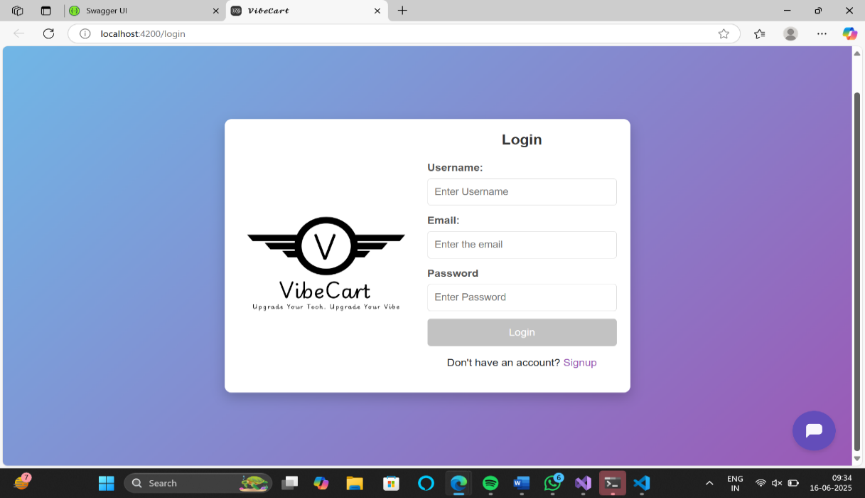

Fig. 2.2 shows the Homepage of Vibecart. It displays the categories, search bar, and user specific profile.

**Fig. 2.**

**2**

**:**

**VibeCart Home Page**

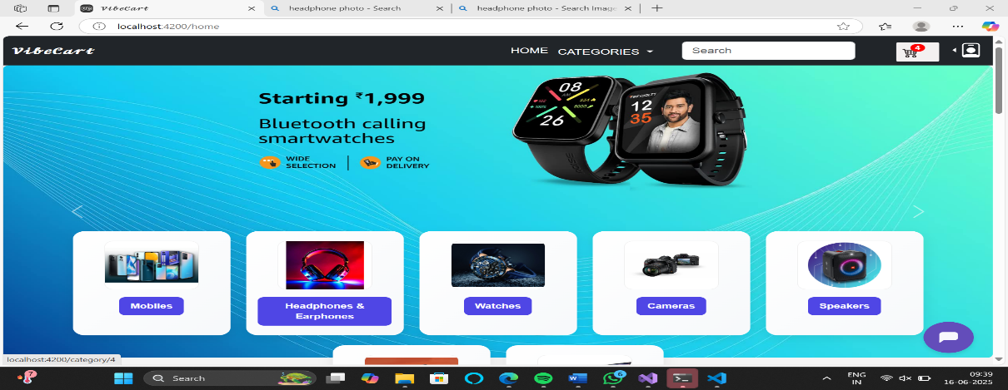

Fig. 2.3 shows the product listing, which displays the name, description and price of specific product in rupees .

**Fig. 2.3: Product Listing Page of VibeCart**

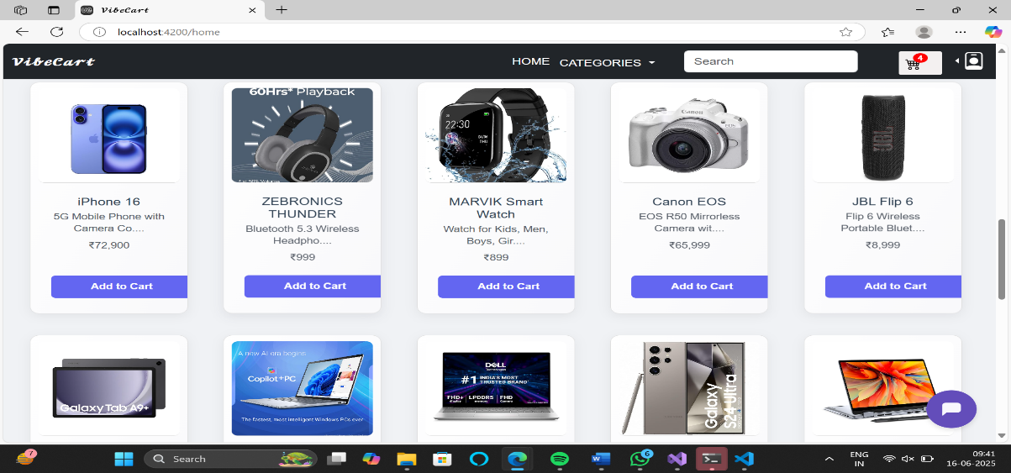

The best seller section shown in fig. 2.4, displays the top selling products of VibeCart based on the total number of quantities of products sold in total orders, it gets updated regularly.

**Fig. 2.**

**4**

**:**

**Best Seller Section of VibeCart**

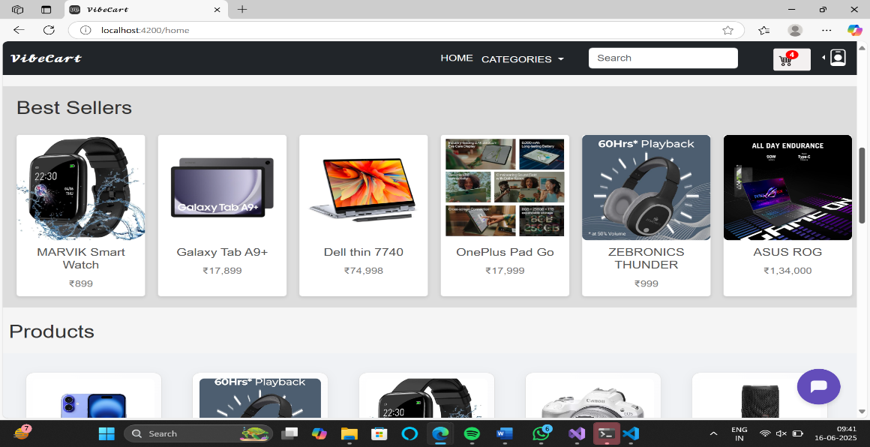

Fig. 2.5 shows the Chatbot implemented using Botpress AI,. This chatbot is trained using workflows and is trained to answer only site specific questions.

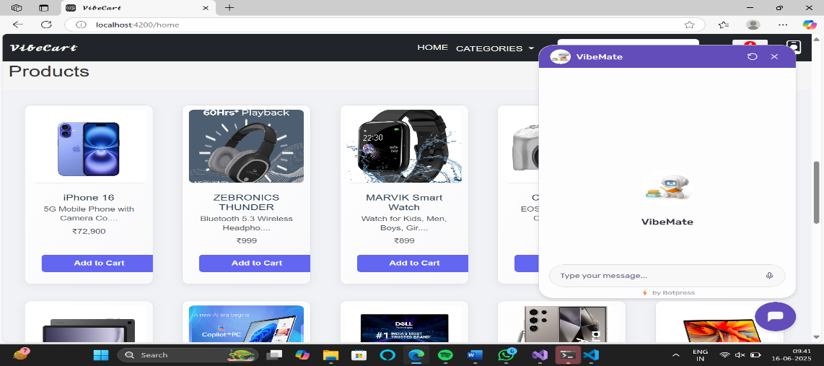

**Fig. 2.5: AI Chatbot (VibeMate)**

Fig. 2.6 displays the user specific account section which stores the user’s name, mobile number and address**.**

**Fig. 2.**

**6**

**:**

**User Specific Account Section**

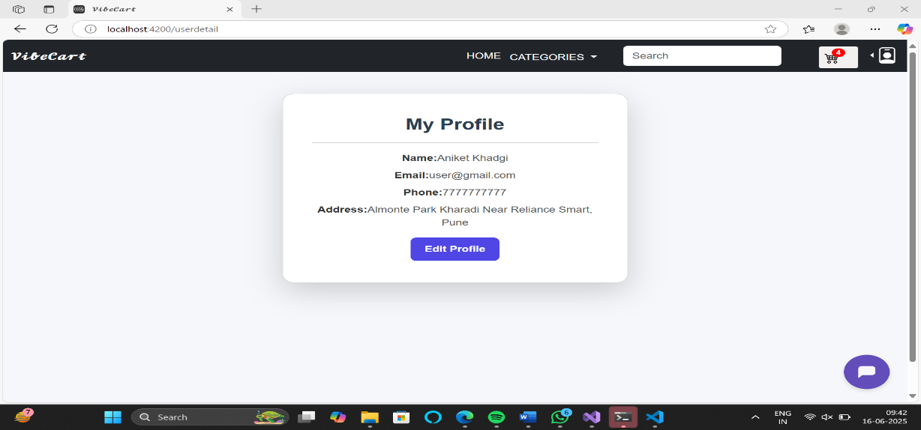

The fig. 2.7 displays user specific cart which allows users to update quantity, buy a single item or checkout multiple products.

**Fig. 2.**

**7**

**:**

**User Specific Cart**

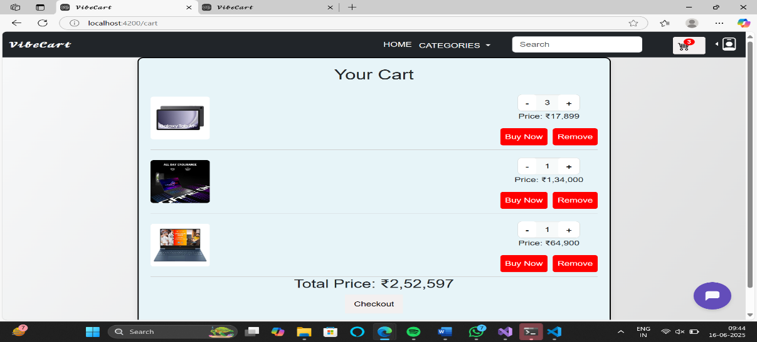

**F**

**ig 2.**

**8:**

**Admin Dashboard**

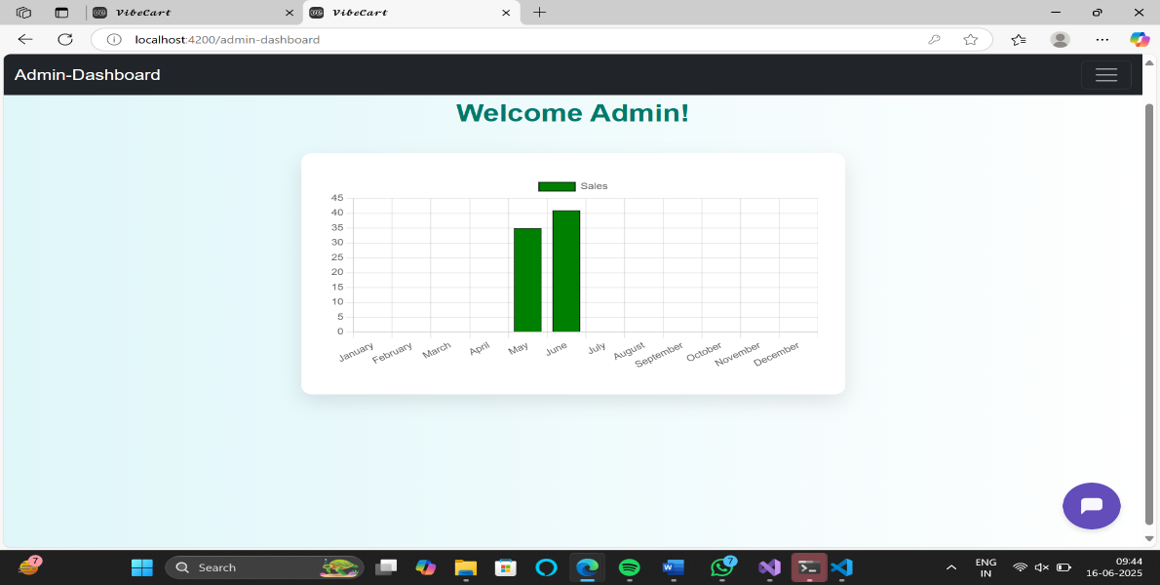

**Fig 2.9: VibeCart Admin Orders**

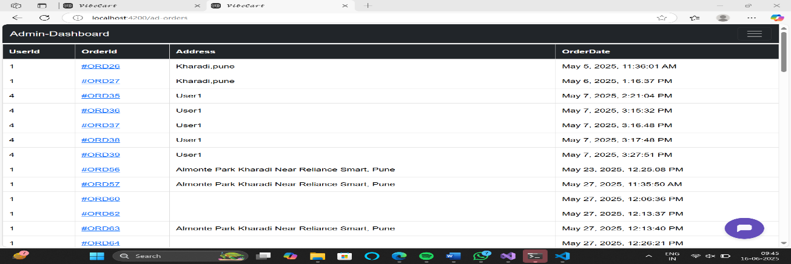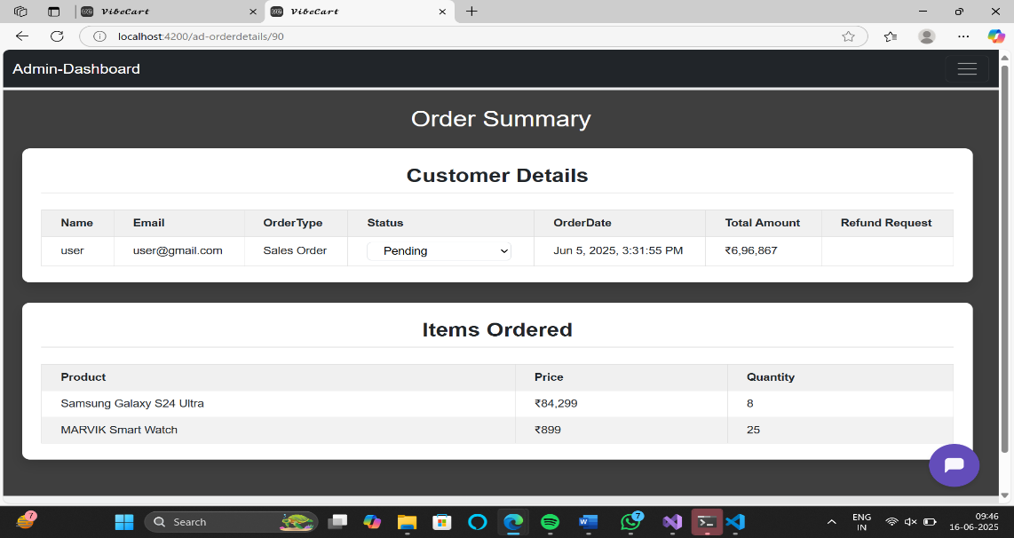

**Fig 2.10: VibeCart Admin Order Details**

### 2.7.2 Conclusion

The project not only met academic expectations but also prepared the developer (me) with practical experience in software engineering. The system is ready for deployment and further expansion such as admin dashboards, vendor portals, and AI-based recommendation engines.

# References

1. MicrosoftDocs – ASP.NET Core Web API  
   <https://learn.microsoft.com/en-us/aspnet/core/web-api>
2. Angular Official Documentation  
   https://angular.io/docs
3. Stripe API Documentation – Refunds  
   <https://stripe.com/docs/api/refunds>
4. Entity Framework Core – Microsoft Docs  
   <https://learn.microsoft.com/en-us/ef/core/>
5. W3Schools – Web Development Tutorials  
   <https://www.w3schools.com>
6. GeeksforGeeks – Full Stack Project Resources  
   <https://www.geeksforgeeks.org>
7. Hitachi Enterprise Chat

# APPENDICES

**A. Photo with Industry Guide**

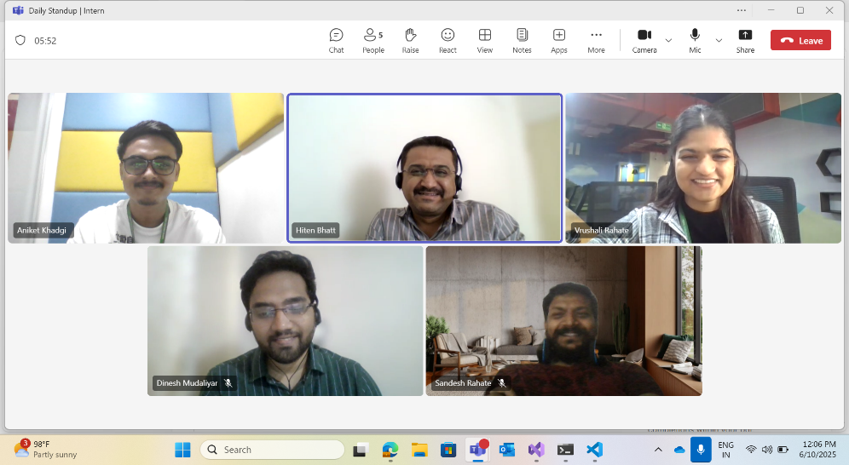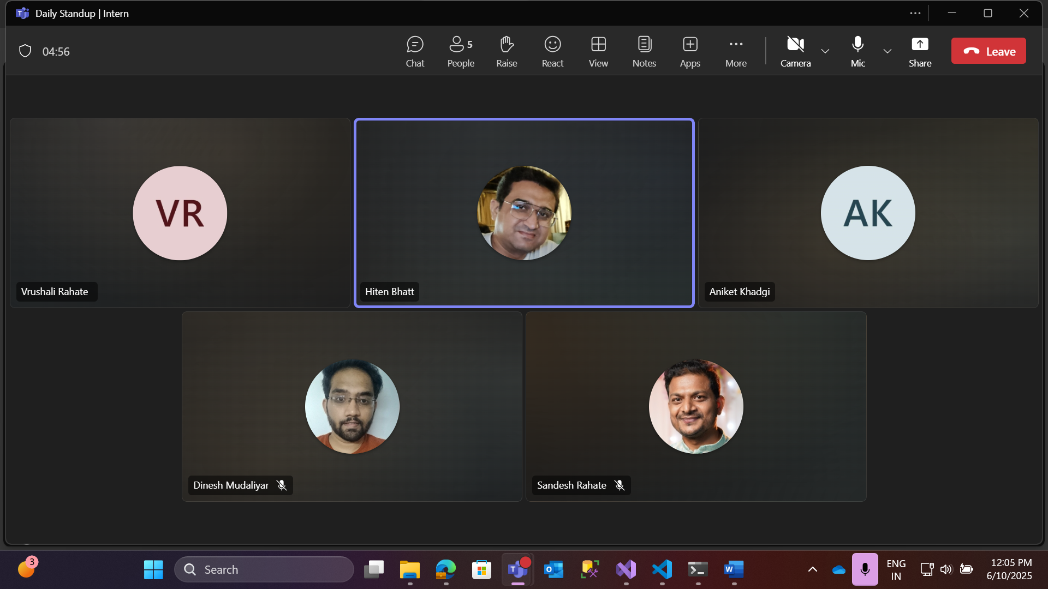

25